**Minshall Family**

5830 Irish Ave, Cloverdale, OR

To: Tillamook County Planning Commission

From: Edmund Minshall, local resident (part-time)

Date: 5 September 2019

Subject: Facebook Corporation’s Application for Conditional-Use in Residential/Rural Area

I wish to express my opposition to the proposed corporate & commercial use of a residential tax lot in Tierra Del Mar. I live part-time just 2 doors away from the proposed project-site, at 5830 Irish Ave. I do understand Facebook’s desire to develop the Jupiter project, but a small residential lot is inappropriate for this type of construction. It’s quite clear that the global appetite for data & connectivity is increasing, therefore the corporations supporting this market must continue to invest in the necessary hardware. However, this concentrated communications infrastructure does not belong in a residential community. Speaking with my neighbors, I am not alone in this sentiment. The points below represent my personal strongest-objections … other neighbors have differing perspectives and concerns. My primary objections are as follows:

1. The proposed intercontinental cable landing-site does not meet the spirit of RR-2 zoning
2. Security concerns place the neighborhood-character at-risk

RR-2 Zoning: like any other legal document, zoning regulations must be stable & predictable, despite the evolving world around us. At the time our zoning regulations were crafted, county planners clearly sought to preserve the quiet, rural nature of Tierra Del Mar. RR-2 zoning is clearly established to designate the area as residential and agricultural. Items which may be conditionally approved are presumably included with the intent of supporting that same local community. While intercontinental cable-crossings have been deployed for many years, it’s those drafting our zoning regulations could not possibly have predicted the explosive growth in Data-Communications brought on by the internet. It makes sense to allow a power sub-station or telephone transmission lines to support a quiet neighborhood. It simply does not make sense to land an intercontinental data-backbone on a residential lot! The Jupiter project should be moved to a commercial or state-owned location, leaving the sleepy community of Tierra Del Mar peaceful and quiet.

Community Character and Security: presently, in the US, Beach Man Holes (BMH’s) appear to be unsecured. However, none of us can predict future security requirements. There are several examples indicating that we should expect future developments in site-security requirements:

* The US government has recently threatened to block Google/Facebook from connecting one of their submarine cables due to the possibility of international data-hijacking.
* The Jupiter cable will be landed in Japan at a high-security site – reasons undisclosed. Looking at the NTT Communications facility (they are one of Facebook’s partners on this project), the guards and fences have no place in our rural community. See image below.  
  NTT Communications press release: <https://www.ntt.com/en/about-us/press-releases/news/article/2017/1030.html>
* The Australian government has designated cable landing sites as critical infrastructure for national security.

While these types of facilities are not mentioned/foreseen in the Facebook conditional-use application, they are entirely predictable. This sort of structure should not be next-door to anyone’s house.

I strongly urge the planning commission to vote against this particular site for Facebook’s Jupiter project. There are dozens of other companies building/landing submarine cables in other locations … Facebook needs to try harder and find a more suitable location for this project.

Respectfully,

Edmund Minshall

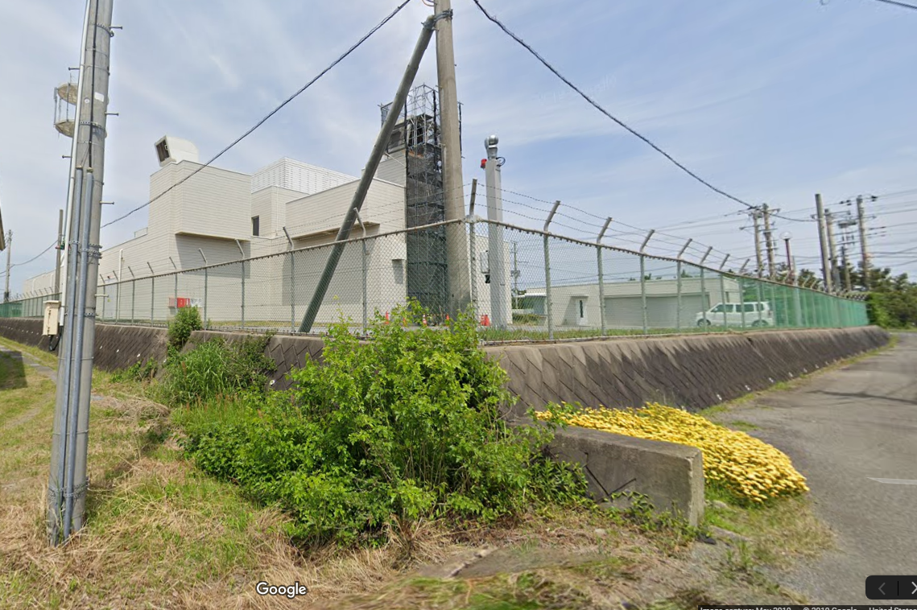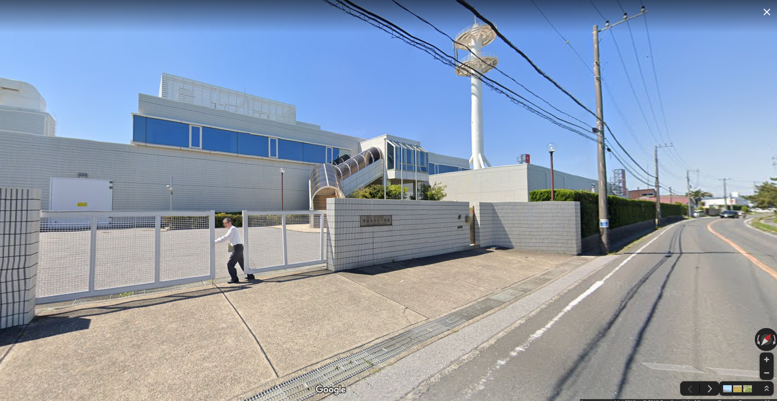**Pictured**: NTT’s Maruyame high-security landing site for Jupiter (Japan)